Chatterbox activities Summer term 1 2023
This term we are looking at growing and life cycles. We will also be doing some work on the Coronation of the King
Week beginning April 17th 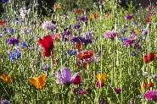
Do you have a book about gardens or flowers (fiction or non-fiction). Bring it in to share at story time.
Week beginning April 24th
What can you see growing in your garden/ plant container/park. Ask mum/dad to take a photo or help you to draw what you can see growing and post onto tapestry/bring into nursery. Do you have a favourite flower, what is it called?. Can you name the different parts of a flower? How long does a flower last?
Week beginning 02nd May 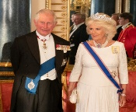
The Coronation of His Majesty The King and Her Majesty The Queen Consort will take place at Westminster Abbey on Saturday 6th May, 2023.
The Coronation Big Lunch, at which neighbours and communities are invited to share food and fun together, will take place across the country on the same date. On Monday, 8th May 2023, members of the public will be invited to take part in The Big Help Out, which will encourage people to try volunteering for themselves and join the work being undertaken to support their local areas.
Can you think of something that you and your family can do to help others?
Week beginning 08th May 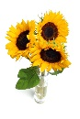
We will be finding out about famous artists who painted flowers and encouraging the children to create their own paintings of flowers. With your child look at some of the paintings of flowers by Van Gogh, Monet, O’Keefe, visit a museum and see if there are any paintings of flowers on display.
Week beginning 15th May 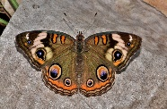
We will be looking at the butterfly life cycle this week. Have a look at images of a caterpillar or butterfly, looking closely at the colours and patterns and create your own caterpillar or butterfly- what materials will you use? Bring your creation to nursery.
Week beginning 22nd May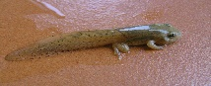
This Photo by Unknown Author is licensed under CC BY-SA
Go on a nature walk to an allotment/park/farm/wood/countryside. See if you can find some insects/animals etc in different life cycle stages e.g. caterpillars, tadpoles etc.

Week beginning 29th May 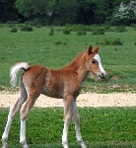
This is half term week. Lots of baby animals have been born in spring. Visit the countryside/farm. Did you see any baby animals?
Can you name the baby animal names for the following: duck, frog, sheep, chicken, horse, pig, cow,
What other baby animals can you name? Cut out pictures of animals and their babies and make a book to bring to nursery after the half term break.

